WEB REPORT 8
Group: SE-2429
Name: Daryn Musseyev

Project Report: HR Management System – Home Page
2. Home Page
Purpose:
Welcomes users and provides navigation to main sections: About Us, Career, Operators, and Contact.
Structure:
- Header: Logo, title, and mobile menu button.
- Navigation Bar: Main site links.
- Main Content: Welcome text describing system goals.
- Footer: Copyright.
Features:
- Responsive design using Bootstrap grid.
- jQuery slideToggle() animation for mobile menu.
- Clean, consistent layout and color scheme.
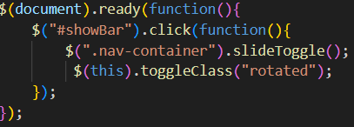
About Us Page
Purpose:
Introduces Rhodes Island Pharmaceuticals and provides an interactive overview of operator classes (e.g., Caster, Defender, Guard).
Structure & Design:
- Same header, nav, and footer for consistency.
- Each operator class includes an image, description, and a collapsible jQuery panel for extra details.
- Responsive two-column layout adapting to smaller screens.
Interactivity:
- jQuery accordion effect for class panels.
- Smooth animations and responsive navigation.
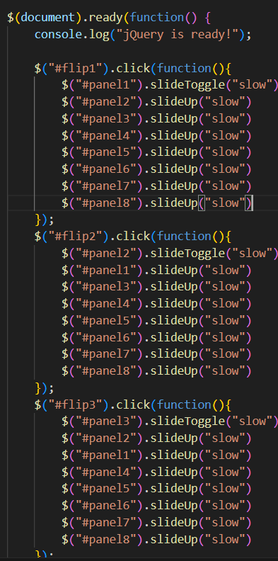
Career Page
Career Page
Purpose:
Functions as a recruitment form for applicants to submit personal and professional data.
Main Elements:
- Header & Nav: Consistent layout.
- Info Section: Instructions for applicants.
- Form Section: Fields for personal info, file uploads, and operator class selection.
Validation:
- HTML5 required fields and email format checks.
- JavaScript validation prevents incomplete submissions.
- Bootstrap feedback highlights invalid fields.
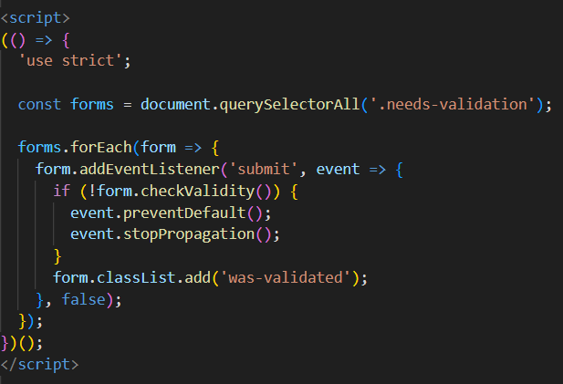
Operators Page
Operators Page
Purpose:
Displays operator profiles in a card-based personnel directory.
Layout:
- Responsive Bootstrap grid with operator cards (image, details, quote).
- Lightbox gallery using jQuery for full-size image viewing.
Functionality:
- Clickable images open lightbox with next/prev navigation.
- Smooth fade transitions and responsive modal scaling.
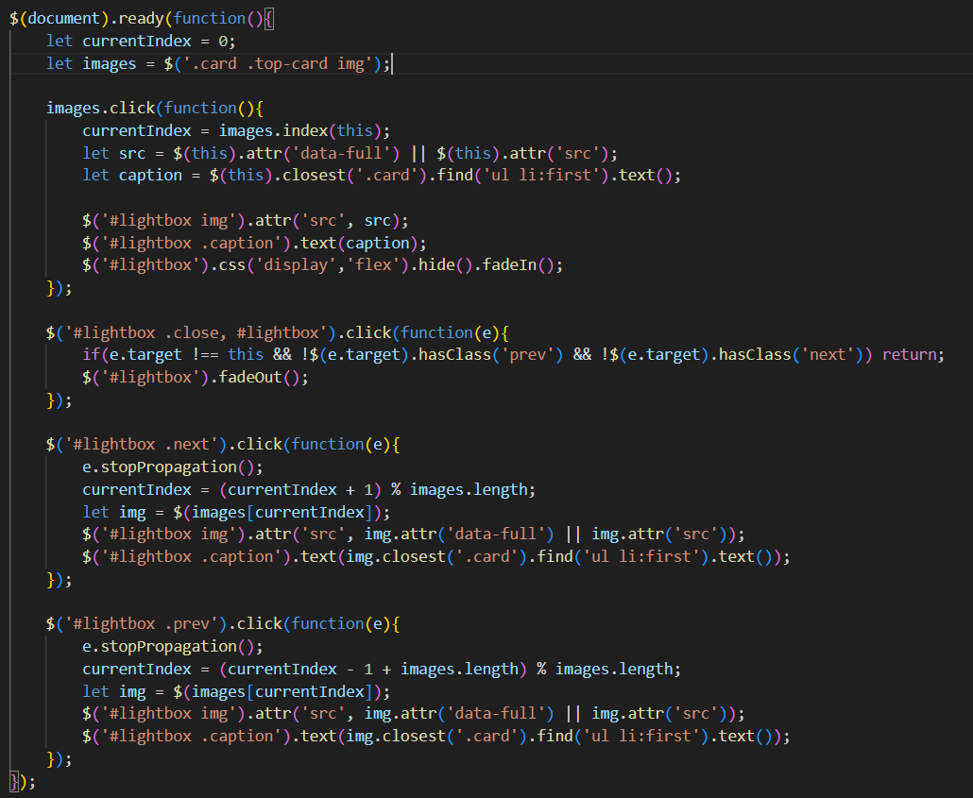
Contact Page
Purpose:
Provides communication channels for General Inquiries, Recruitment, and R&D, along with a contact form for messages.
Structure:
- Header: Logo, title, mobile menu toggle.
- Navigation Bar: Links to Home, About Us, Career, Operators, Contact.
- Main Content:
  - Contact info (emails, phone)
  - Operations overview
  - Contact form with Name, Email, Message
- Footer: © 2025 Rhodes Island HR Department.
Form Validation:
- HTML5 required fields + email format checks.
- JavaScript prevents submission if invalid, adds .was-validated for feedback.
Interactivity:
- jQuery slideToggle for mobile menu.
- Client-side validation feedback for real-time guidance.
Key Features:
- Professional, unified layout.
- Accessible communication channels.
- Responsive form and smooth mobile navigation.

